All We Do is Talk Steel: Oral Histories of Sparrows Point is a new collection of interviews with workers from the world’s largest steel mill, which closed in 2012. These interviews emphasize the epic civilization of the steelworkers—their efforts to build a union, the campaigns to bring civil right and women’s right into the union—and the efforts to oppose these campaigns, and the families and communities they created.
The workers interviewed are:
- Neal Crowder
- Margaret “Mugs” Rytter
- Lee Douglass
- Joe Kotelchuck
- Edie Papadakis Butler
- Eddie Bartee, Sr.
- Mary Lorenzo
- LeRoy McClelland
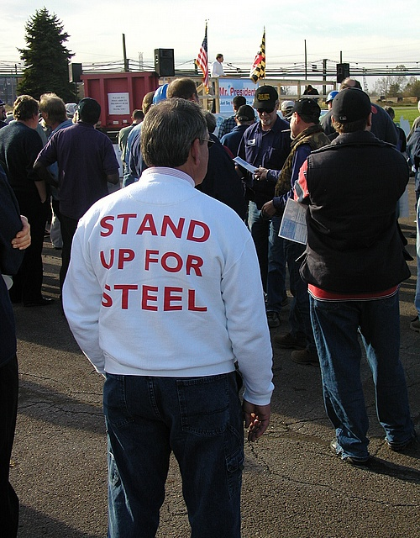
There is also a Glossary, explaining steeltalk, to anyone not from the industry.
The book, 148 pages long, developed from classes I taught to the steelworkers over the years, and is hopefully the first of a series about these steelworkers. I just hope that these transcripts share some of the excitement of the original interviews.
The hardcopy book is $10.00 and can be purchased in the usual ways: from Amazon on-line, from me by mail for an extra $3.00 postage if you want a signed copy—(send check to 4204 Elsrode Ave, 21214) or you can drop by the house, with a 6-pack for us to share, and pick one up. There is also a Kindle version.

